**David Tran**

**CSC 600**

**Hw 1 Syntax**

**Dr. Jozo Dujmovic**

**2/13/17**

**1. Using BNF write the syntax definitions of the following objects:**

**(a) Natural number (1, 2, 3, …)**

<natural number> ::= <natural digit> | <natural> <digit>

<natural digit> 1|2|3|4|5|6|7|8|9

<digit> ::= 0|1|2|3|4|5|6|7|8|9

**(b) Unsigned integer (0, 1, 2, 3, …)**

<unsigned int> ::= <digit> | <unsigned int> <digit>

<digit> ::= 0|1|2|3|4|5|6|7|8|9

**(c) Integer (…, -2, -1, 0, 1, 2, …)**

<integer> ::= <sign> <unsigned> | <integer> <unsigned>

<unsigned int> ::= <digit> | <unsigned int> <digit>

<digit> ::= 0|1|2|3|4|5|6|7|8|9

<sign> ::= + | - | <empty>

<empty> ::=

**(d) Odd number (…, –3, -1, 1, 3, …)**

<odd number> ::= <sign> <unsigned int> <odd digit>

<unsigned int> ::= <digit> | <unsigned int> <digit>

<odd digit> ::= 1|3|5|7|9

<digit> ::= 0|1|2|3|4|5|6|7|8|9

<sign> ::= + | - | <empty>

<empty> ::=

**(e) Even number (…, –4, -2, 0, 2, 4, …)**

<even number> ::= <sign> <unsigned int | <integer> <even digit> | <even number> <even digit>

<unsigned int> ::= <digit> | <unsigned int> <digit>

<even digit> ::= 0|2|4|6|8

<digit> ::= 0|1|2|3|4|5|6|7|8|9

<sign> ::= + | - | <empty>

<empty> ::=

**(f) Integer divisible by five (…, -10, -5, 0, 5, 10, …)**

<integer divisible by 5> ::= <sign> <value>

<sign> ::= + | - | <empty>

<empty> ::=

<value> ::= 0 | <prefix> <suffix>

<prefix> ::= <empty> | <prefix> <digit>

<digit> ::= 0|1|2|3|4|5|6|7|8|9

<suffix> ::= 0|5

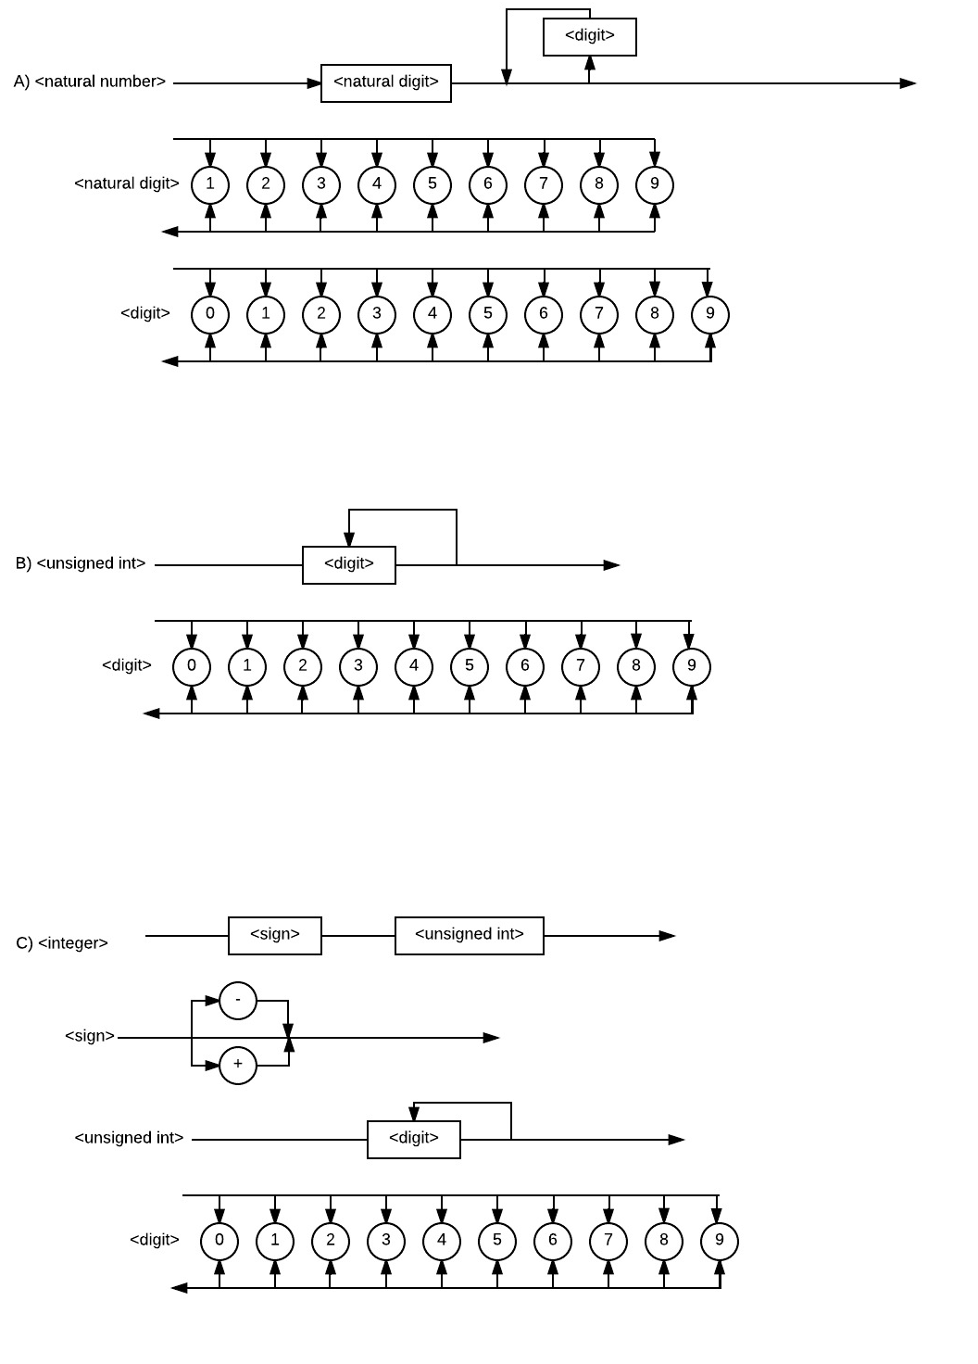

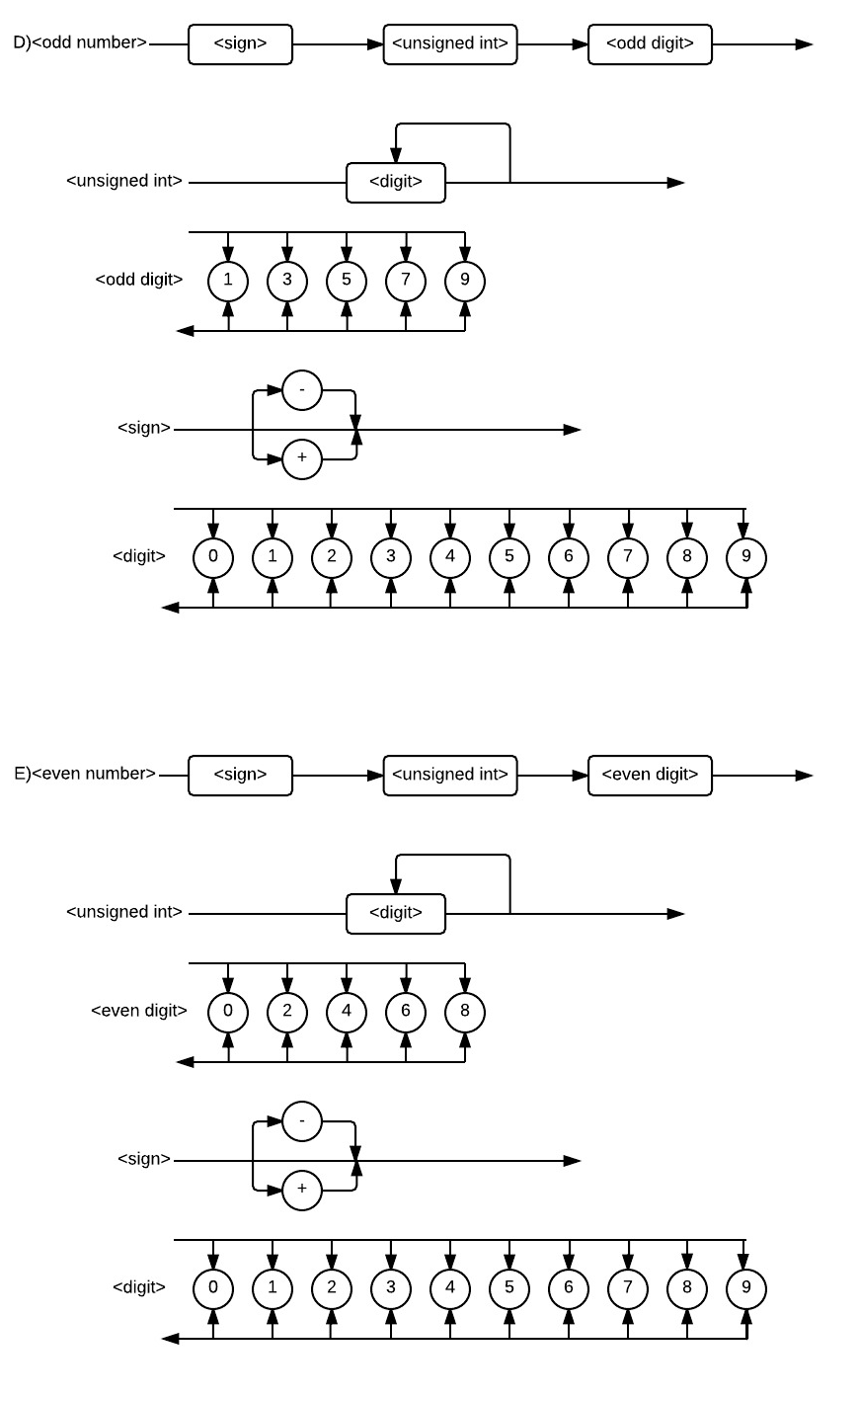

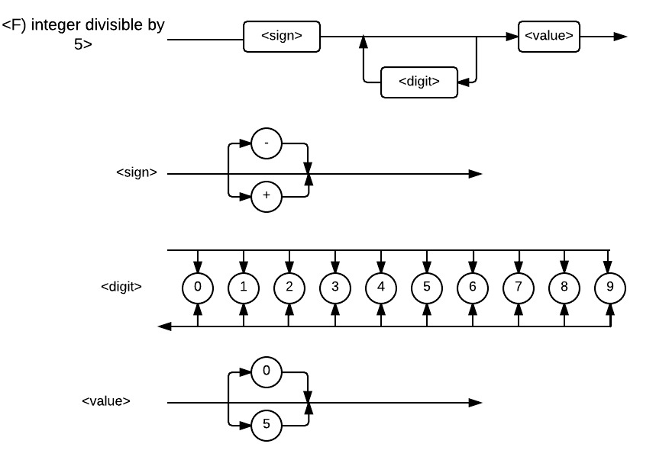

**3. Following is an example of input statement in C++ (subscripts can be expressions):**

**cin >> sclr >> vec[2*i-1] >> mat[f(i)][j+k] >> t[i/3][j][k];**

**Write a BNF definition of the syntax of (all possible) input statements in C++.**

<input statement> ::= cin >> <input> ;

<input > ::= <simple expression> | <input> >> <simple expression>

<simple expression> ::= <variable> | <array> | <function>

<variable> ::= <letter> | <variable> <character>

<character> ::= <letter> | <digit>

<array> ::= <variable>|<array> <subscript>

<subscript> ::= [<expression>]

<expression> ::= <simple expression> | <digit> | <arithmetic>|<integer>|“<string>”|‘<character>’

<arithmetic> ::= <operand> <operator> <operand> | <arithmetic> <operator> <operand>

<operand> ::= <simple expression> | <integer> | <real>

<operator> ::= + | - | * | / | % |&

<real> ::= <integer> . <integer>

<integer> ::= <sign> <digit> | <integer> <digit>

<string> ::= <variable> | <string> <space> <variable>

<space> ::= “ “

<function> ::= <variable> ( <parameter> )

<parameter> ::= <expression> | <parameter> , <expression> |<empty>

<sign> ::= + | - | <empty>

<letter> ::= a|b|c|d|e|f|g|h|i|j|k|l|m|n|o|p|q|r|s|t|u|v|w|x|y|z|

A|B|C|D|E|F|G|H|I|J|K|L|M|N|O|P|Q|R|S|T|U|V|W|X|Y|Z

<digit> ::= 0|1|2|3|4|5|6|7|8|9

<empty> ::=

**4. Following is an example of output statement in C++:**

**cout << 12.34*a/rate << “ “ << 43.21 << “ “ << alpha + x[2*i-1] << “ “**

**<< (p && q) << “ “ << pow(t[i][j], 1.2) << " string " << 's' << “ “**

**<< myfun(x, sin(x+y), third_argument) ;**

**Write a BNF definition of the syntax of C++ output statements.**

<output statement> ::= cout << <output> ;

<output> ::= <simple expression> | <output> << <simple expression>

**NOTE: <simple expression> defined in problem number 3.**